# CUSTOMER CARE REGISTRY TEAM ID : PNT2022MID42135

**ABSTRACT**

The main idea is to implement an online system for managing the internet customers and complaint system for customers for raising complaints on the issues related to ISP provider and provide best customer care service for users using this application. There are many Internet security providers in a country that will provide internet services for users on different packages. Basically ISP works on three connections, Dial Up using telephone service, Broad band and wireless connections. Admin manages the whole system by performing task such as adding/viewing/editing/deleting employee details. System allows admin to add customer details and predict the internet plans based on their business type, region or age. Internet plan expiry dates of each customer will be displayed to admin if the plan is expiring in 5 days. All the complaint details will be displayed to the admin as well as employee to enter the complaint resolution. Employee can login using valid id and password which is provided by the admin. After login, employee can view all the unsolved complaints received from the customers. After resolving the complaint, employee can update the provided resolution and close the complaint. Once the complaint is closed, an email will be sent to customer will resolution details. After receiving the mail, customer can view the resolution and can post the feedback to this application. Admin can view the report of complaint resolution provided by the employee.

# INTRODUCTION

* 1. **PROJECT OVERVIEW**

Internet is gaining more importance day after day in all life aspects, especially in business and marketing due to the amazing increase in internet users around the world with an estimate of 2.4 billion users in 2012, when comparing this number to the number of internet users in 2000, a growth of 566% can be noticed. This is making internet the fastest media of all time in both growth rate and number of users (internet world stats, 2012). Based on a comprehensive study in 2011, the number of advertisements circulated over the net was more than 3.5 million daily. Internet became one of the most efficient ways to conduct business. In developed and well-developed countries, internet proved to be of much help for local enterprises where it provides great potential for such enterprises to compete worldwide. The main idea is to implement an online system for managing the internet customers and complaint system for customers for raising complaints on the issues related to ISP provider and provide best customer care service for users using this application. There are many Internet security providers in a country that will provide internet services for users on different packages. Basically ISP works on three connections, Dial Up using telephone service, Broad band and wireless connections.

# PURPOSE

The main idea is to implement an online system for managing the internet customers and complaint system for customers for raising complaints on the issues related to ISP provider and provide best customer care service for users using this application. By adding more entries to the data base store, the application can respond to more number of queries from the customers. The importance is given on giving correct reply to the input queries.

# LITERATURE REVIEW

* 1. **EXISTING PROBLEM**
     1. **TITLE:** Design of Internet Provider E-CRM System on CV. Ahyein Pratama Mandiri Air Joman

**AUTHOR:** Irfan Hakim Nasution1

Currently conducts its business activities by waiting for customers to come to the office or customers providing information about places, privileges and products to other potential customers. Inadequate reporting of customer complaints makes it difficult to know the level of customer satisfaction, causing the opportunity to get potential customers to the maximum not to be fulfilled. Dissemination of information that is not neat makes it difficult for customers to know the latest information, thus influencing customers to switch to other providers. Therefore CV. Ahyein Pratama Mandiri requires CRM (Customer Relationship Management) which is applied to the information system, where this system can facilitate CV. Ahyein Pratama Mandiri in managing services for customer satisfaction. In carrying out this research, the researcher uses a qualitative research method which is a method that discusses the problem by describing, interpreting and writing down a situation or event that will be analyzed and then draw a general conclusion from the problems discussed. As a result, the application of CRM on CV. Ahyein Pratama Mandiri can make it easier for companies to provide information to consumers, provide convenience in ordering products that can be done anytime and anywhere, and increase customer loyalty. Customer relationship management (CRM) is a special type of management that addresses theories for managing the relationship between a business and its customers and for improving customer relationships to achieve growth. Healthy business development . CRMs are designed to improve profits, sales, and customer satisfaction by helping businesses of all kinds accurately identify their customers, attract more customers, and maintain customer loyalty. A business strategy that includes customized software and services. CRM is a sales, marketing and service strategy that uses information technology through a customer-centric corporate philosophy and culture to make business processes more efficient . Information is data

processed in a form that is significant to the recipient and has real value that can be perceived in making decisions now or in the future.

* + 1. **TITLE:** The impact of the magnitude of service failure and complaint handling on satisfaction and brand credibility in the banking industry

**AUTHOR:** Ghazal Shams1 · Mohsin Abdur Rehman

The present research aims to investigate the efects of service failure and complaint handling on customer satisfaction with complaint handling which consequently impacts overall satisfaction and brand credibility. To examine the objectives of the present research, the authors deployed a sample of 384 respondents in Persian banks within Iran. Structural equation modeling has been used to analyze the data. The fndings suggest that the magnitude of service failure negatively efects customer satisfaction with complaint handling. Complaint handling positively afects customer satisfaction with complaint handling. In addition, the results suggest that customer satisfaction with complaint handling positively infuences brand credibility and overall satisfaction. Finally, overall satisfaction positively impacts brand credibility. The results revealed that if the complaint handling occurs instantly at the right time, it would have been a positive infuence on customer satisfaction and ultimately develop brand credibility. Therefore, banks can adopt customer relationship management systems and processes which enable quick responses to customer complaints. Bank managers could fnd the results of the present study useful and benefcial in developing complaint handling eforts and expanding appropriate service recovery and brand credibility strategies. stakeholders involved in the service process. Service recovery follows service failure and helps business to recover the damaged service experience. An efective service recovery strategy transforms the existing service processes to avoid the recurrence of a service failure Service sector adopts more technological advancements to tailor customers dynamic expectations However, business service processes are facing numerous challenges to sustaining brand value

* + 1. **TITLE:** Exploring the influence of the human factor on customer satisfaction in call centres

**AUTHOR:** Dorina Chicua,∗, Maria del Mar Pàmies

The aim of this study is to explore the human or employee-related factors that shape customer satisfaction in the context of call centres. The literature review draws from a range of disperse disciplines including Service Quality, Human Resource Management and Marketing. The empirical study explores the different variables identified to obtain a nuanced analysis of the employee-related paths that lead to customer satisfaction in call centres. The study employs data from 109 call centres and utilises PLS for our exploratory purposes. Call centre managers should note that investing in HR practices will pay off in terms of improving the elusive phenomenon of customer satisfaction within call centres. The call centre industry is a peculiar service industry, in as much as it is almost entirely based on a voice-to-voice encounter between the employee and the customer, on opposite ends of the telephone line. In general, customers are less satisfied with the service they receive from call centres than from the more traditional brick n’ mortar, or face to face service encounters In call centres, employees (call centre operators) are the main connection between the organization and the customer. Employees are often required to undertake many different tasks at the same time. They are expected to display ambidextrous behaviour, being able to accomplish managerial requirements such as: maintaining service quality, including attentiveness, perceptiveness, responsiveness and assurance, satisfy customers, solve problems attend a large number of calls in a short time while ensuring first call resolution.

* + 1. **TITLE:** Analyzing and Implementing a System For Reporting, Follow Up and Resolving of Complaints

**AUTHOR:** Angham AL Abbas, Khadeeja Alzayer

In every aspect of life either it is personal or professional we use internet. It makes life easier, and overcomes unsatisfactory and unacceptable services or issues on various fields. We can use online complaint management system which is considered as an essential part of quality services. Complaints and compliments are valuable sources of information that organizations can use it to improve program delivery and service. “A web system for reporting, follow-up and resolving of complaints” is a web application analyzed and developed for managing various complaints in any place such as universities, hospitals shopping centers, damaged roads, unwanted load Shedding or sewerage proble…. etc. This work aims to make complaints easier to be reported, coordinated, monitored, tracked and resolved, and to provide governments with effective tool to keep records of complaint data, to use them for identifying problem areas and to improve services. Today's development cycles for web- applications such as Portals and Marketplaces are short, and getting shorter with continuous improvements and enhancements as new requirements and features become apparent. Therefore, developing “Web Services” using the “Service-Oriented Architecture” paradigm is a widely accepted concept. On the other side, most of user’s complaints are apparent when a system has inappropriate communication between the organizations, their employees and customers (Citizens). Poor communication can result in poor services or products being provided by the organization or Government. Whilst concentrating on the topic of complaint handling, organizations can achieve an efficient success factor by increasing their user satisfaction and their loyalty. Therefore each organization needs to develop its internal and external communication towards its staff and customers to achieve success. Although appropriate communication can reduce user dissatisfaction; it cannot eliminate complaint

* + 1. **TITLE:** Leveraging unstructured call log data for customer churn prediction

**AUTHOR:** Nhi N.Y. Vo a , Shaowu Liu b , Xitong L

Customer retention is important in the financial services industry. Machine learning has been incorporated into customer data analytics to predict client churn risks. Despite its success, existing approaches primarily use only structured data, e.g., demographics and account history. Data mining with unstructured data, e.g., customer interaction, can reveal more insights, which has not been adequately leveraged. In this research, we propose a customer churn prediction model utilizing the unstructured data, which is the spoken contents in phone communication. We collected a large-scale call center dataset with two million calls from more than two hundred thousand customers and conducted extensive experiments. The results show that our model can accurately predict the client churn risks and generate meaningful insights using interpretable machine learning with personality traits and customer segments. We discuss how these insights can help managers develop retention strategies customized for different customer segments. Customer relationship management (CRM) has always been a core business function for any company. Among the components of CRM, increasing customer engagement and loyalty is one of the most challenging tasks. Although customer acquisition and retention are both important, prior research has showed that acquiring a new customer is typically five times more expensive than retaining an existing customer. Because of the high cost of customer acquisition, established businesses focus more on customer retention instead of acquisition. In customer retention, predicting customer churn risk is an important task. Each single percentage increase in customer churn prediction accuracy could potentially lead to a substantial revenue saving. This is particularly true for the financial services sector in which each customer may contribute to a considerable amount of profits, while customer engagement and loyalty are relatively low.

# REFERENCES

1. Irfan Hakim Nasution1, Design of Internet Provider E-CRM System on CV. Ahyein Pratama Mandiri Air Joman, 2022.
2. Ghazal Shams1 · Mohsin Abdur Rehman,The impact of the magnitude of service failure and complaint handling on satisfaction and brand credibility in the banking industry, 2020.
3. Dorina Chicua,∗, Maria del Mar Pàmies,Exploring the influence of the human factor on customer satisfaction in call centres, 2018.
4. Angham AL Abbas, Khadeeja Alzayer, Analyzing and Implementing a System For Reporting, Follow Up and Resolving of Complaints, 2019.
5. Nhi N.Y. Vo a , Shaowu Liu b , Xitong L,Leveraging unstructured call log data for customer churn prediction, 2020.

# PROBLEM STATEMENT DEFINITION

Call center management is the way in which organizations manage the daily operations of call center, including forecasting, scheduling, employee training, reporting and all customer interactions. Call center management can be modernized with workforce optimization (WFO) solutions. A call center management system refers to a software solution that helps improve customer interactions, service levels, and user experience. Simply put, it’s a modern way of managing the day-to-day call center operations-training, forecasting, reporting, scheduling, and many others. Callers should be able to leave messages in cases where all agents are preoccupied and no one can take the call**.** A call center functions through operators, known as agents or sometimes customer representatives, and computerized telephony (CTI).

# IDEATION & PROPOSED SOLUTION

* 1. **EMPATHY MAP CANVAS**

An empathy map is a simple, easy-to-digest visual that captures knowledge about a user’s behaviours and attitudes.

It is a useful tool to helps teams better understand their users.

Creating an effective solution requires understanding the true problem and the person who is experiencing it. The exercise of creating the map helps participants consider things from the user’s perspective along with his or her goals and challenges.

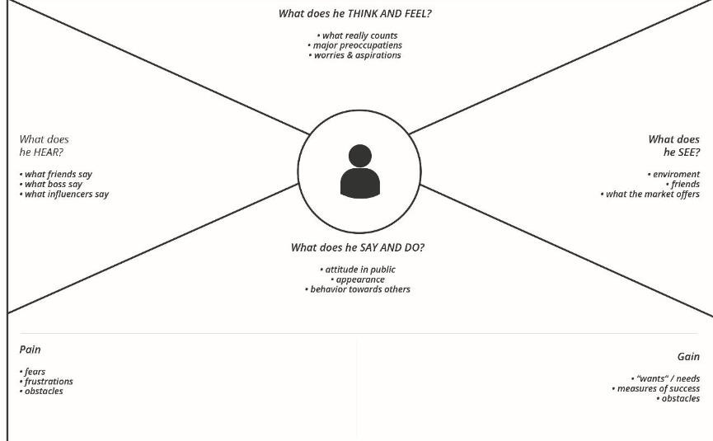

# IDEATION & BRAINSTORMING

Brainstorming provides a free and open environment that encourages everyone within a team to participate in the creative thinking process that leads to problem solving. Prioritizing volume over value, out-of-the-box ideas are welcome and built upon, and all participants are encouraged to collaborate, helping each other develop a rich amount of creative solutions.

Use this template in your own brainstorming sessions so your team can unleash their imagination and start shaping concepts even if you're not sitting in the same room.

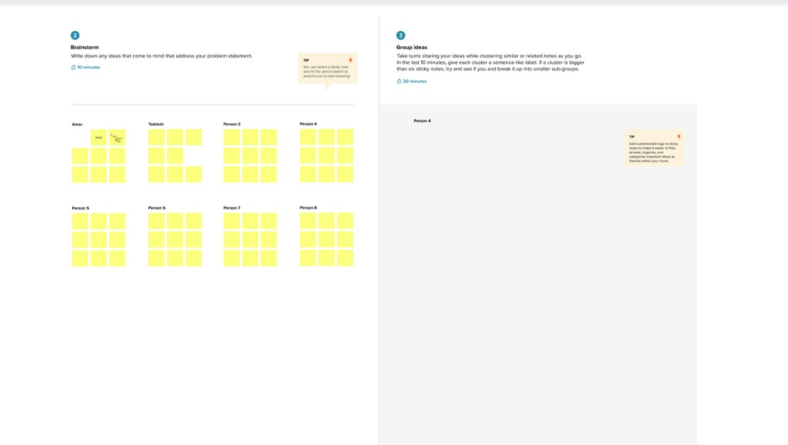

# PROPOSED SOLUTION

This proposed system provides an online way of solving the problems faced by the public by saving time and eradicate corruption, and The ability of providing many of the reports on the system, and add to Facilitate the process of submitting a complaint. In this project we can design web application to analyze the complaints and to provide automatic forwarding system of user’s complaints. User is easily known about status of complaints. If the action can’t be taken properly means, send to higher authorities. The proposed system is supposed to handle as more number of customers as possible in any particular time. The mail service is also provided to have a communication between the admin and the users. The user queries should be periodically referred and the solution should be provided quickly.

# PROBLEM SOLUTION FIT

The existing system is handled manually. The system has a formatted call centre management for customers in paper work like files and document format. The customers are waiting a call to taken by the call centre employee pick their calls. So any urgent work we didn’t get any important response from the call centre. So the proposed system the manager will look after it and then he will take care about the customer’s problems. After that the manager will enquire and allocate the problem to the specified person in that department. The person will enquire the problem and then rectifies it.

# REQUIREMENT ANALYSIS

* 1. **FUNCTIONAL REQUIREMENT Admin**
     + Login
     + Add Employees
     + Add Customers
     + View Details
       - Employees
       - Customers
       - Feed Back

# Employee

* + - Login
    - View Complaints
    - Send Notification ( Through Email)
    - View Feed Back

# Customer

* + - Login
    - Post Complaint
    - View Notification
    - Feed Back

# MODULE DESCRIPTION

**Admin**

* + - Login

In this module, the admin can login in the system using his/her username and password.

* + - Add Employees

In this module, the admin can add the employee information like employee name, id, phone number, mail id, location etc.

* + - Add Customers

In this module, the admin can add the customer information like customer name, id, phone number, mail id, location etc.

* + - View Details

In this module, the admin can view the employee details, customer details and feedback details.

# Employee

* + - Login

In this module, the employee can login in the system using his/her username and password.

* + - View Complaints

In this module, the employee can view the customer complaint using this application.

* + - Send Notification ( Through Email)

The employee can sent the notification to the user through the email for update status of the complaint using this system.

* + - View Feed Back

In this module, the employee can view the user feedback.

# Customer

* + - Login

In this module, the customer can login in the system using his/her username and password.

* + - Post Complaint

In this module, the customer can post the internet service related complaint to this system.

* + - View Notification

If the employee can update the status of the complaint, the user can get the automatic notification.

* + - Feed Back

In this module, the user can post the feedback of products or service.

# NON FUNCTIONAL REQUIREMENTS

**Non - Functional Requirements Usability**

The system shall allow the users to access the system with pc using web application. The system uses a web application as an interface. The system is user friendly which makes the system easy

# Availability

The system is available 100% for the user and is used 24 hrs a day and 365 days a year. The system shall be operational 24 hours a day and 7 days a week.

# Scalability

Scalability is the measure of a system's ability to increase or decrease in performance and cost in response to changes in application and system processing demands.

# Security

A security requirement is a statement of needed security functionality that ensures one of many different security properties of software is being satisfied.

# Performance

The information is refreshed depending upon whether some updates have occurred or not in the application. The system shall respond to the member in not less than two seconds from the time of the request submittal. The system shall be allowed to take more time when doing large processing jobs. Responses to view information shall take no longer than 5 seconds to appear on the screen.

# Reliability

The system has to be 100% reliable due to the importance of data and the damages that can be caused by incorrect or incomplete data. The system will run 7 days a week. 24 hours a day.

# PROJECT DESIGN

* 1. **DATA FLOW DIAGRAMS**

A data-flow diagram is a visual representation of how data moves through a system or a process (usually an information system). The DFD additionally gives details about each entity's inputs and outputs as well as the process itself. A data-flow diagram lacks control flow, loops, and decision-making processes. Using a flowchart, certain operations depending on the data may be depicted.

# LEVEL 0

It is also known as a context diagram. It’s designed to be an abstraction view, showing the system as a single process with its relationship to external entities. It represents the entire system as a single bubble with input and output data indicated by incoming/outgoing arrows.

**CUSTOMER CARE REGISTERY**

Database

Customer

Admin

Employee

# LEVEL 1

In 1-level DFD, the context diagram is decomposed into multiple bubbles/processes. In this level, we highlight the main functions of the system and breakdown the high-level process of 0-level DFD into sub processes.

Login

Store the data

Add employee

details

Store the data

Add customer

details

Store the data

View details

Retrieve the data

**Admin**

# LEVEL 2

2-level DFD goes one step deeper into parts of 1-level DFD. It can be used to plan or record the specific/necessary detail about the system’s functioning.

Login

Store the data

View

Complaints

Store the data

Send Notification

(Through Email)

Retrieve the data

Feedback

Store the data

**Employee**

# LEVEL 3

A data flow diagram (DFD) is a graphical representation of the flow of data through an information system. A DFD shows the flow of data from data sources and data stores to

processes, and from processes to data stores and data sinks. DFDs are used for modelling and analyzing the flow of data in data processing systems, and are usually accompanied by a data dictionary, an entity-relationship model, and a number of process descriptions.

Login

Store the data

Post

complaint

Store the data

View

notification

Retrieve the data

Feedback

Store the data

**Customer**

# SOLUTION & TECHNICAL ARCHITECTURE



**Data Base**

View Report

View details

View feedback

Feedback

View details

View notification

Sent

notification

Add customers

Post complaint

View complaint

Add employee

Login

Login

Login

**Customer**

**Employee**

**Admin**

**CUSTOMER CARE REGISTRY**

* 1. 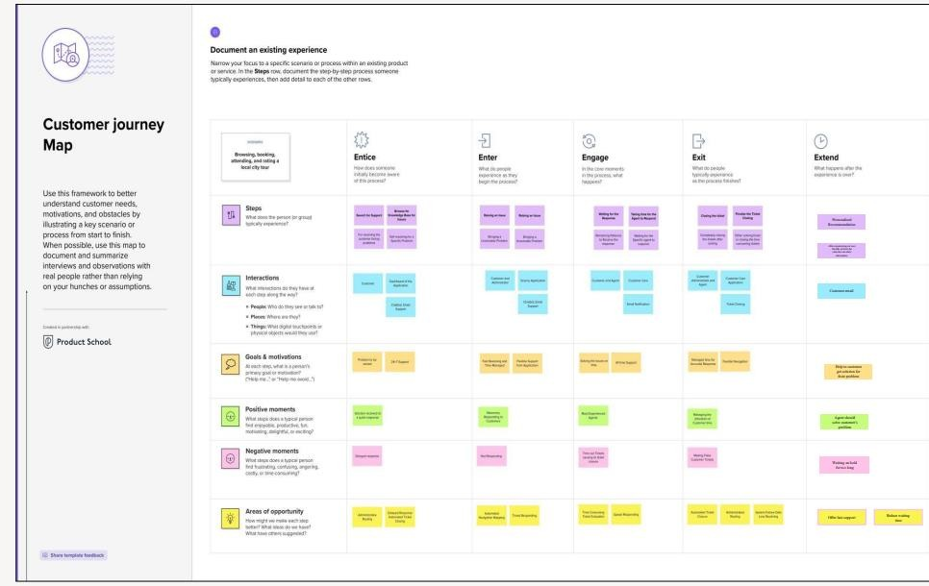**USER STORIES**

# PROJECT PLANNING & SCHEDULING

**6.1 SPRINT PLANNING & ESTIMATION**

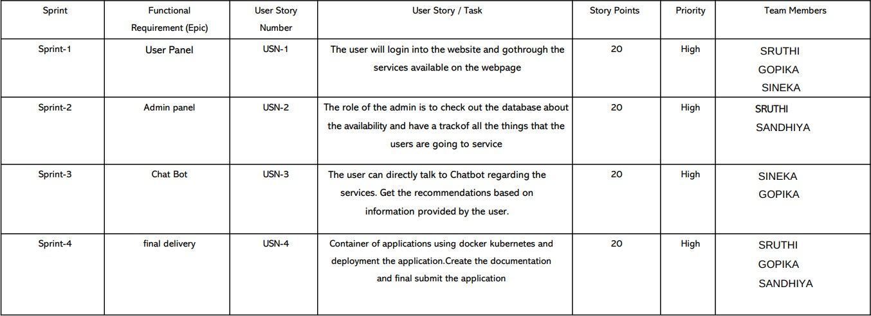

# CODING & SOLUTIONING

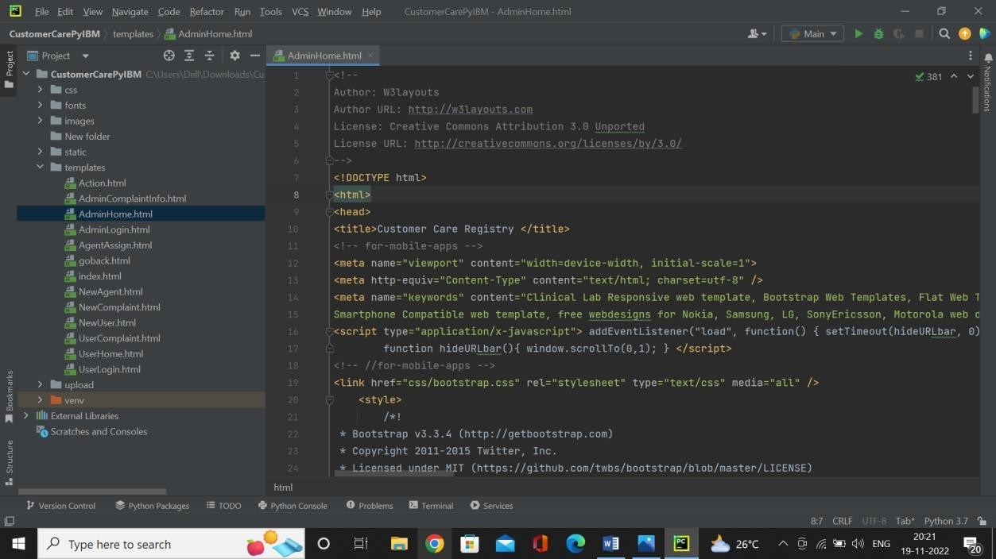

* 1. **TESTING**

# TEST CASES

A test case has components that describe input, action and an expected response, in order to determine if a feature of an application is working correctly. A test case is a set of instructions on “HOW” to validate a particular test objective/target, which when followed will tell us if the expected behavior of the system is satisfied or not.

Characteristics of a good test case:

* + - Accurate: Exacts the purpose.
    - Economical: No unnecessary steps or words.
    - Traceable: Capable of being traced to requirements.
    - Repeatable: Can be used to perform the test over and over.
    - Reusable: Can be reused if necessary.

|  |  |  |  |  |
| --- | --- | --- | --- | --- |
| **S.NO** | **Scenario** | **Input** | **Excepted output** | **Actual output** |

|  |  |  |  |  |
| --- | --- | --- | --- | --- |
| 1 | Admin Login Form | User name and password | Login | Login success. |
| 2 | Employee Login Form | User name and password | Login | Login success. |
| 3 | User Registration Form | User basic details | Registered successfully | User basic details  are stored in the database. |
| 4 | User Login Form | User name and password | Login | Login success. |

# USER ACCEPTANCE TESTING

This is a type of testing done by users, customers, or other authorised entities to determine application/software needs and business processes. Acceptance testing is the most important phase of testing as this decides whether the client approves the application/software or not. It may involve functionality, usability, performance, and U.I of the application. It is also known as user acceptance testing (UAT), operational acceptance testing (OAT), and end-user testing.

# RESULTS

* 1. **PERFORMANCE METRICS**

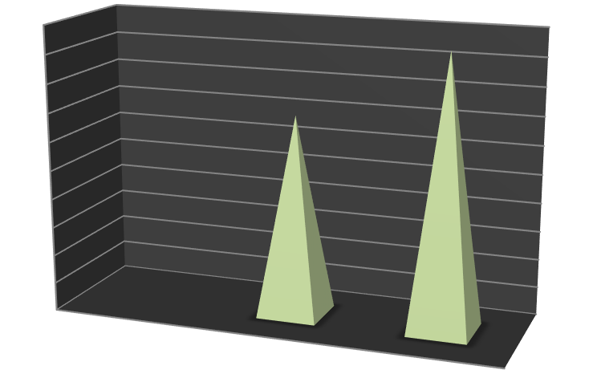

100

90

80

70

60

50

40

30

20

10

0

Series2

Series1

TIME

CONSUMPTION THROUGH

MAIL

THROUGH CALL

# ADVANTAGES & DISADVANTAGES

**DISADVANTAGES**

* + - Requires an active internet connection.
    - System may provide inaccurate results if the data entered incorrectly.
    - Difficult to provide proper intimation system
    - Current system is manual process
    - Cannot always taking a call
    - Tower problem during call conversation

# ADVANTAGES

* + - System is easy to understand and user friendly.
    - The system is purely based on prediction which predicts an internet plan for the customer.
    - Admin can easily view employee report based on the resolution provided on the complaint.
    - Handle large number of contextual information.
    - User friendly and time consuming process.
    - Using this project, the user can know about status of complaint through website.
    - Keep track of daily information exchange at the server by the administrator.
    - Increase in processing and transfer speeds of information over the network.

# CONCLUSION

Application software has been computed successfully and was also tested successfully by taking “test cases”. It is user friendly, and has required option, which can be utilized by the user to perform the desired operations. Application meets the information requirements

specified to a great extent. The system has been designed keeping in view the present and future requirements in mind and made very flexible. The goals that are achieved by the software are Instant access, improved productivity, Optimum utilization of resources, Efficient management of records, Simplifications of the operations, Less processing time and getting required information, User friendly, Portable and flexible for further enhancement. The system has the benefits of easy access because it is be developed as a platform independent web application, so the admin can maintain a proper contact with their users, which may be access anywhere. All communications between the police and administrator has done through the online, so this communication cost also is reduced.

# FUTURE SCOPE

In future we can develop this project in android application with extra features like customer complaint system and collect the feedback form from the customer about the system.

# APPENDIX

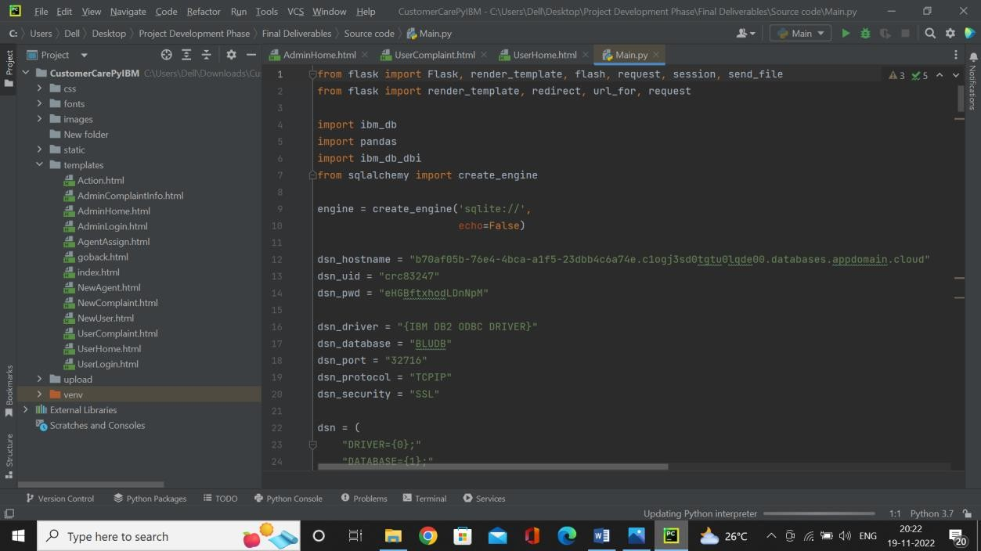

**GITHUB & PROJECT DEMO LINK**

# https://github.com/IBM-EPBL/IBM-Project-53717-1661490319